Bolton Communication Friendly Environments – Settings Audit
How does your environment support children’s communication?
Elements to consider:
Space, light and layout; | Evidence | Action | Date completed
Is there good light, with a comfortable temperature?
Have you considered sunlight from windows and how it moves around the room? (This will have an impact on how easy it is for children to see your face as light from behind casts a shadow).
How easy is it for the child to see you and other children when speaking and when listening?
Do you have few visual distractions near areas where you are trying to focus on speaking and listening skills?
All labels and instructions are on eye level height therefore can be easily seen?
Have a small well defined quiet area that children can use to talk and form relationships, this may be a book corner, temporary den or comfortable area with soft cushions and furnishings.
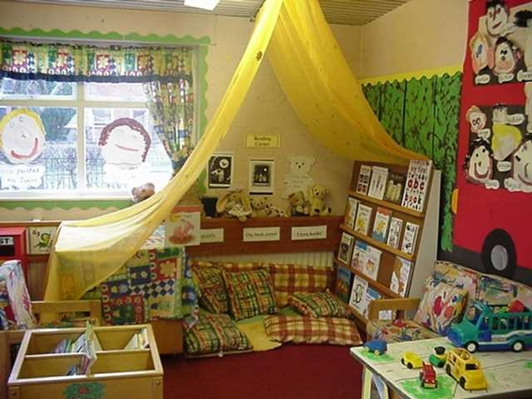

Have sufficient space for children to sit and move comfortably.
Noise levels:
Are noise levels conducive to learning – what can be done to minimise unnecessary noise?
Which are the noisiest/quietest areas of your setting, or times of the day that are noisier or quieter than others? What can you do about these?
Is there constant noise in the setting which could be turned off e.g., music.
There is an awareness of auditory distractions e.g., heater/open windows.
There is a good acoustic environment for children to listen.
Use of visual support, this may include:
Do you use photographs/symbols to support routines, e.g., washing hands.
Visual timetables used for daily/weekly activities.
Objects, pictures, and symbols used to teach vocabulary, to make stories more active.
Room/area is organised, resources labelled clearly with photographs /symbols/objects?
Have displays that children want to talk about. Consider a space (wall/table) where objects, photos or paintings can be displayed. Giving children the opportunity to help with the display will encourage interaction with both children and parents.
What visual reminders do you have (at child’s level) about good speaking and listening skills? (For older children).
Routines:
Are children aware of rules and expectations.
Do they know daily routines; could these be supported visually?
How easy is it for the child to get your attention?
Does the child need to ask you for specific resources?
Are children given opportunities to say when they don’t understand.
Is the child able to tell you when something is not working – e.g., a piece missing from a jigsaw?
Are they explicitly taught how to listen and take turns?

Further information on supporting communication within your environment is available from:
- www.elizabethjarman.co.uk
- www.hello.org.uk

